Contributor: Imma Ramos

Guzmán**, Cecilio**

Born Cecilio Guzmán de Rojas: 1889 – Potosí; Died: 1950 – La Paz

Cecilio Guzmán de Rojas is regarded as a pioneer and ‘father’ of *indigenism* or *indigenismo* in Bolivia, a term used to describe a movement that gained momentum in Latin America from the 1920s onwards. It consisted of a valorisation of indigenous cultural traditions, reflected in literature and the visual arts, as well as a desire to shed light on the plight of indigenous peoples living under exploitative conditions. As a highly influential artist and teacher, Guzmán de Rojas encouraged the establishment of a quintessentially Bolivian national art that would have its roots in pre-Columbian culture and aimed to foster a sense of community. This was reflected in his portraits of Aymara Indians in particular, often portrayed in formal, frontal poses and in native dress as noble and dignified embodiments of a national ideal. The most famous examples of such portraits are *Ñusta* (1932) and *Cristo Aymara* (1939). Ñusta is the Quechua name for an Inca princess, and Guzmán de Rojas uses it in his title to invoke a past grandeur before the arrival of Spanish colonial rule. His use of vivid, arbitrary colours and stylistic distortions across his oeuvre to evoke moods and emotions also reveals the influence of European avant-garde movements including Post-Impressionism, Cubism and Expressionism.

In 1912 Guzmán de Rojas studied at the Academy of Painting in Cochabamba under Avelino Nogales. He became actively involved in politics in 1921 when he founded a labour syndicate, the Socialist Workers’ Party of Bolivia, but was discouraged by the fact he was unable to effectively improve workers’ conditions. *El Mendigo (The Beggar)* of 1919 represents a critique of the social and political forces that oppressed the indigenous population in Bolivia: an elderly and proud Aymara Indian is shown dressed in rags, directly appealing to the viewer with his grim and penetrating gaze.

With the support of a scholarship, Guzmán de Rojas travelled to Europe and studied at the School of Fine Arts in Barcelona (‘La Lonja’) and at the Royal Academy of San Fernando in Madrid during the 1920s. At the latter, he studied under the Spanish Symbolist Julio Romero de Torres. His impact on Guzmán de Rojas’s work is revealed in his paintings portraying women, as in for example *The Idol’s Kiss* (1928), a romanticised and eroticised image of the pre-Columbian past. During this time, the artist also studied at the Escuela de Bellas Artes in Paris. His contact and experimentation with a variety of different European artistic styles including Symbolism, Art Nouveau, Art Deco, Cubism and Expressionism merged with his own indigenous vision, resulting in a unique and personal visual idiom.

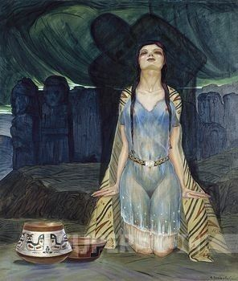

Cecilio Guzmán de Rojas, *The Idol’s Kiss*, 1928, oil on canvas, Casa de la Moneda (Potosí).

Source: <http://wwwdelivery.superstock.com/WI/223/4435/PreviewComp/SuperStock_4435-1442.jpg>

During the 1920s Guzmán de Rojas employed a vibrant palette to portray Bolivia’s ancient past in symbolic terms. His *Triunfo de la Naturaleza (Triumph of Nature)* (1928), executed in Spain before his return to La Paz, represents an indigenous couple leaning against a carved stone monument of the Andean and Inca god Viracocha. Their nakedness and apparent state of sleep suggest the birth of a new age, an idealisation of the past pre-Hispanic splendour of Andean society. The vivid colours of the landscape and swirling patterns reveal the influence of the French Expressionist Vincent van Gogh as well as Guzmán de Rojas’s own stylistic penchant for what he termed “sensuous rhythms.”

[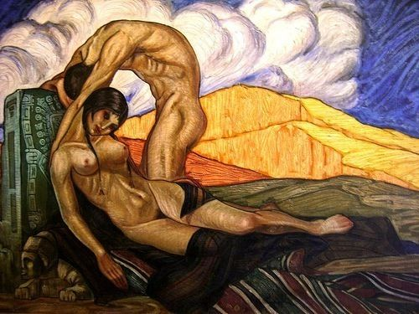](http://4.bp.blogspot.com/-osYn8xX2Quc/T8dRS3QrYPI/AAAAAAAAH6o/yDw4KZnL-Mw/s1600/El+triunfo+de+la+naturaleza,+1928..jpg)

Cecilio Guzmán de Rojas, *El Triunfo de la Naturaleza,* 1928, oil on canvas, Museo Nacional de Arte (La Paz).

Source: <http://4.bp.blogspot.com/-osYn8xX2Quc/T8dRS3QrYPI/AAAAAAAAH6o/yDw4KZnL-Mw/s1600/El+triunfo+de+la+naturaleza,+1928..jpg>

Returning to Bolivia in 1931, Guzmán de Rojas became director of the Hernando Siles National Academy of Fine Arts in La Paz and the following year he was named General Director of Fine Arts of Bolivia by the president, Hernando Siles. During the 1930s, Guzmán de Rojas worked with the Ministry of Education’s Department of Artistic Heritage to focus on the protection, preservation and revival of Bolivian art heritage and the cataloguing of artworks from the pre-Columbian and colonial periods. He also discovered and identified the works of the seventeenth-century Potosí colonial artist Melchor Pérez de Holguín**.** During the 1940s he told the traveller Lilo Linke:

*We classified and properly valued the works of art and passed a law to protect all archaeological ruins, declaring them national monuments (…) The popular arts represent a cultural and artistic tradition which give Bolivia her individual appearance and strengthen her national consciousness. The servile imitation of European models can only lead to disintegration (…) What I have been defending and putting into practice in my own work is a new unity of modern Indian and colonial elements. (…) Our modern American art should be rhythmical, simplified, space-covering, at big strokes and not lost in detail, almost sculptural, and in neutral colours. Apart from all this, it should express a certain collective feeling (…) Out of all this will grow the Indo-American school.*

In 1934, Guzmán de Rojas was sent to fight in the Chaco War between Bolivia and Paraguay over border issues (1932-35). Thousands of members of the indigenous community died at the front. He documented the atrocities and horrors he witnessed in around 300 highly expressionistic works (in the form of studies, drawings, oils and watercolours). The use of bold brushstrokes, distorted forms and dark palette make for harrowing, confrontational and stark images.

Guzmán de Rojas’s fascination with Inca culture and the blending of European modernist styles would continue well into the 1940s. In 1942 he travelled to Machu Picchu to draw and paint the Inca ruins. His studies of the archaeological site (in oil, pencil and pastel) were inspired by Paul Cézanne and executed in a Cubist style, using the techniques of faceting, passage (the blending of overlapping planes into one another) and multiple viewpoints.

In the mid-1940s the British Council awarded him a scholarship to study restoration in London. During this time he became interested in a technique he termed *coagulatoria*, inspired by investigating the works of Leonardo da Vinci and other Old Masters. He died at the age of fifty in the Llojeta Valley of La Paz in 1950.

**Further reading**:

Barnitz, J. (2000) *Twentieth-century art of Latin America*. Austin: University of Texas.

Calvo Valda, M. (1986) *Mistica y paisaje: ensayos sobre la obra de Cecilio Guzmán* *de Rojas.* La Paz: Librería Editorial ‘Juventud.’

Linke, L. (1945) *Andean Adventure: a social and political study of Columbia, Ecuador and Bolivia*. London: Hutchinson and Co.

Sanjines, J. (2004) *Mestizaje upside-down: aesthetic politics in modern Bolivia.* Pittsburgh: University of Pittsburgh Press.

**List of Works:**

*Self-portrait*, 1918, oil on canvas, Casa de la Moneda (Potosí).

*El Mendigo*, 1919, oil on canvas, private collection.

*El Triunfo de la Naturaleza,* 1928, oil on canvas, Museo Nacional de Arte (La Paz).

*The Idol’s Kiss*, 1928, oil on canvas, Casa de la Moneda (Potosí).

*Ñusta (Inca Princess),* 1932, oil on linen, Fundación BHN (Bolivia).

*Bed 33 TB Available*, 1934, oil on linen, Museo Nacional de Arte (La Paz).

*Cristo Aymara*, 1939, oil on canvas, private collection.

*Machu Picchu*, 1942, oil on linen, Fundación BHN (Bolivia).

*Mujeres Andinas*, 1952, oil on canvas, Museo Nacional de Arte (La Paz).